Making a peascod breastplate
Some people have been asking us how armour is made. Well, we decided to put up this page so those adventurous people can make some of there own. This is in no way a complete guide but we will periodically add some projects that can get you started. Although we prefer to use historical methods we may suggest ones that are more practical to the beginning armourer, i.e. welding.

Making a welded 16th cent. peascod breastplate.
Step one, download the pattern below.
It is 1/4 scale so you will need to enlarge it before printing it.

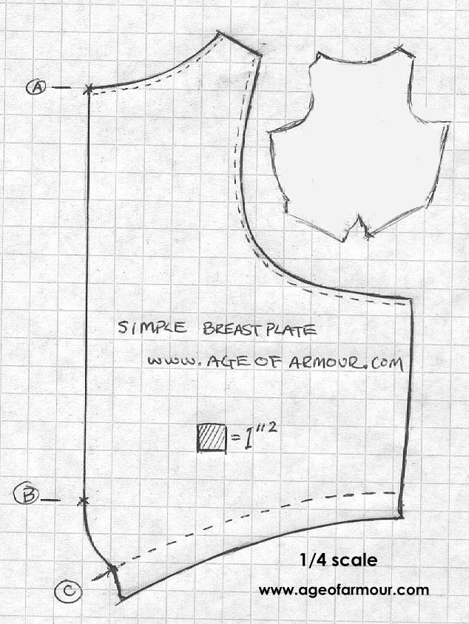 | This pattern was intended for someone approximately 6 foot tall and 185 lbs. We recommend that you cut out a full size pattern on poster board and tape the seam at the bottom to try the fit. Remember that the waist is supposed to be high on the hips, if it isn't it can be real painful after a few hours of wearing it.  The line segment A,B is where the opposite half of the pattern should be attached. The dotted line C is approximately where the bottom of the breastplate will be flared. The other doted lines indicate that these edges should be rolled over.
Step 2, mark out pattern and cut out steel.

We recommend that you use 16 or 14 gage steel, as if it is any thinner it will be hard to weld, wrinkle when dished and will be difficult to flair the bottom.  Be sure to cut out the breastplate in one piece. It's also a good Idea to mark the centreline with a marker at this time. | 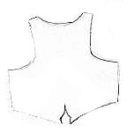

Step 3, Put a slight dish to the plate.

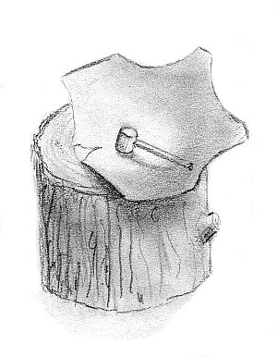 | We use a shallow depression carved in a wood stump about 6" across and 1/2" deep. For making just a slight dish in the breastplate we suggest that you use a heavy soft faced hammer like a "dead blow" or weighted rawhide. This will save a lot of time in sanding and planishing verses using a hard faced hammer.

Step 4, Crease the centre ridge.
Establish the centre ridge by first hammering a blunted or rebated chisel along the inside over the wooden stump. (Not illustrated)  Now sharpen and define the ridge by striking it from the outside with a smooth flat faced hammer over a large chisel shaped stake mounted in your anvil or vice.  Note that the dish in the breastplate is a bit exaggerated in this illustration. | 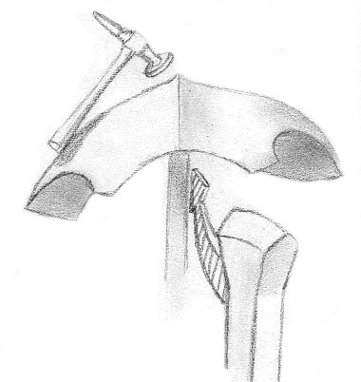
Step 5, Clean up centre ridge.

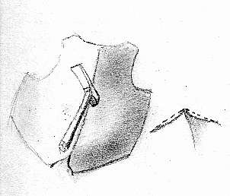 | You will probably have a centre ridge that is slightly concave on either side. To fix this strike it on either side of the ridge from the inside over a smooth anvil. We use a modified Masons hammer for this (illustrated below.) The important thing about the hammer is that it be slightly convex from front to back but have crisp edges on the left and right sides.
Step 6, curve the bottom centre in and weld.
You can probably curve the bottom centre in with a dead blow hammer. If a little more force is needed it can be hammered over a ball stake bending the bottom in so that the seams meet. Weld the inside and outside then clean it up with a slack belt grinder or a file.
Step 7, bend to fit.
You should now bend the sides in so that they fit around your waist snugly. With some effort even 14 gage can be bent over your knee. Be sure to do this now because after the bottom is flared the breast plate will probably be so strong you will not be able to. I find that it gives the best look if the bends radiate diagonally from the centre bottom of the breastplate rather than horizontally across it
Step 8, flair the bottom of the breastplate.

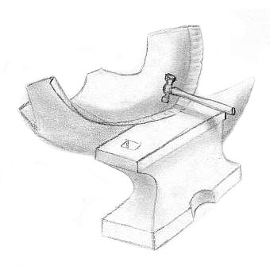

Step 9, roll edges, sand and polish.
Rolling edges takes a lot of practice and polishing gets pretty in-depth so these will have to wait until another issue, sorry.
The finished product... Well with a few decorative things we added,
but it was made from the same pattern.

Modified hammers

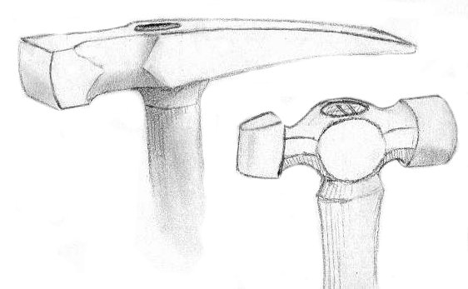 | The hammer on the left is a modified masons hammer. Note that we have ground the face to be slightly curved front to back but flat side to side. We also rebated the back blade. this works well for defining the centre ridge on greaves.  The hammer on the left is a modified ball peen. The ball has been ground to make a blunted horizontal blade. This stretches metal more from side to side than up and down.
Click here to go to the
AGE OF ARMOUR MAIN PAGE
Or here to visit the
AGE OF ARMOUR UPDATE PAGE
We at Age of Armour are interested in preserving the dying art of armour making. If you wish to ad this page to your site please either link to www.crosswinds.net/~ageofarmour or copy this page in its entirety including all text links and images to your host server. Crosswinds.net will not allow these images to be linked directly from another server. Thank you.

